First Ride of 2019-
Mt. Diablo NATRC Competitive Trail Ride Sponsored by CMDTRA
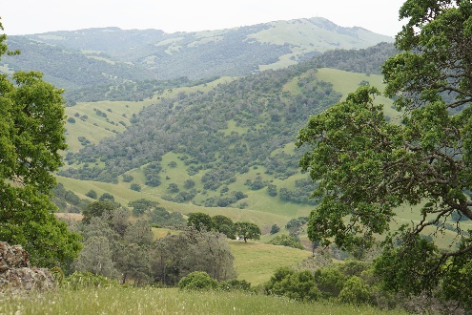
From Ellen Pofcher, 2019 Ride Chair

Hello Everyone,
This year’s NATRC ride is on Saturday May 4th with check-in on Friday May 3rd. This is the Mt. Diablo spring ride and a great opportunity to get out on the trails with your horse and have fun. It’s a rare opportunity to ride through privately owned property including CMDTRA, neighboring ranches as well as State parkland. The views of the valleys and Bay Area are awesome! With all the rain this year, you’ll most likely be winding your way around a green mountain. This year we’ll be offering the new Leisure Division, which is a great introduction to NATRC competitive trail riding and a good option for those experienced competitors who choose not to ride the longer distances. There is a separate entry for the Lesure Division (LeD) ride. You can register using RMS (the on line entry system) or you can print the entry sheet from the Region 1 website www.natrcregion1.org . For more information about the Leisure Division Ride, contact Diane Jorgensen at (925) 408-9700 or email divajorgiegmail.com.

Saturday evening, following the ride, we have a great BBQ tri-tip and chicken dinner and a fun raffle prior to handing out awards and certificates to the riders.

For those of you new to NATRC, NATRC was founded decades ago (1960’s) to promote good trail horses and horsemanship. The very first NATRC ride was held at the Concord Mt. Diablo Trail Ride Association (CMDTRA) when it was located near what is now Highway 680 in Concord. Competitors rode from that location to Mt. Diablo and up to BBQ terrace where they cared for their horses, camped overnight and got up early the next day to ride back to CMDTRA. This ride promotes proper care of horses, proper position of the rider in the saddle on trails and safety for both rider and horse as well as condition, way of going and manners of the horse. Overall, NATRC promotes teamwork between horse and rider. Be a part of NATRC history and ride Mt. Diablo!

This year there are two special things to be aware of :
1. NATRC is offering free membership for those who have not previously been a member. Sign up and you won’t have to pay the non-NATRC member fee on our ride or any other rides this year. Go to www.natrc.org for a membership form. You can fill it out and return it with your entry form.
2. The Diablo Heritage Association (DEHA) will pay one-half of the entry fee- up to $300.00- for the first entry forms received from juniors. Complete the waivers and entry forms for the full amount, but before you write the check call Ellen Pofcher at (925) 672-3733 and you’ll be advised whether or not to include the discount on your check.
For additional information, call the ride chair Ellen Pofcher at (925) 672-3733 or email mtnoaks@earthlink.net

