-
  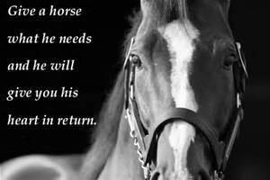
  Equine First Aid Class
  ________Spring Valley Run Stables_________
  April 3, 2021
  9am – 4pm
  Your 1 day clinic is a combination of classroom and hands on.
  It includes course manual and completion certificate.
  $159.00
  What our students are saying about our course….
  “Fantastic class!! Not only did we learn first aid for our horses but also preventative stretching techniques to keep our horses healthy and strong.” Kim Marshall Hill
  Contact: Marsha George, EFAI, AD, CEMTS 513-256-8292
  Brenda Durham, EFAI, AD 513-646-0061
  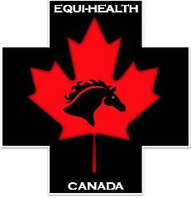
  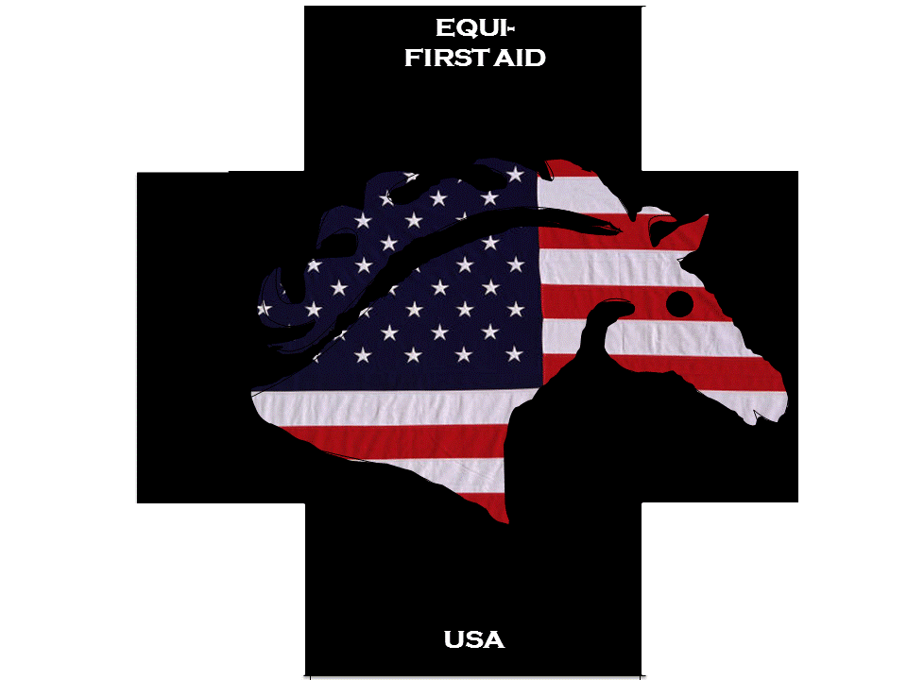
  -
  l
  Learn injury prevention, pain source identification and preparedness !
  Learn the proper way to take vital signs, how to weigh your horse without a weight tape, and what your vet needs to know when you call!
  You’ll also learn the types of wounds and their treatment
  PLUS – colic, choke, collapse, founder, scratches & more!
  [You Have Room for Another One Here!]
  EQUI-FIRSTAID-OHIO
  MARSHA GEORGE
  Marshag8@yahoo.com
  BRENDA DURHAM
  Brendadurham5@aol.com
  FACEBOOK : Equi-firsaid-Ohio

